

Answer Sheet

Full Course Code | AM05
Course Title | Database Management
Faculty | Prof. David Tilson
Date of Exam | 2021-10-22

STUDENT TO COMPLETE BEFORE STARTING EXAM
LBS Number | 3 | 7 | 7 | 5 | 1 | 8 | 3
Stream (if applicable)

QUESTION 1

Answer for 1-1: B
Answer for 1-2: C
Answer for 1-3: E

Answer for 1-4 <Submit screenshot of query and results>:
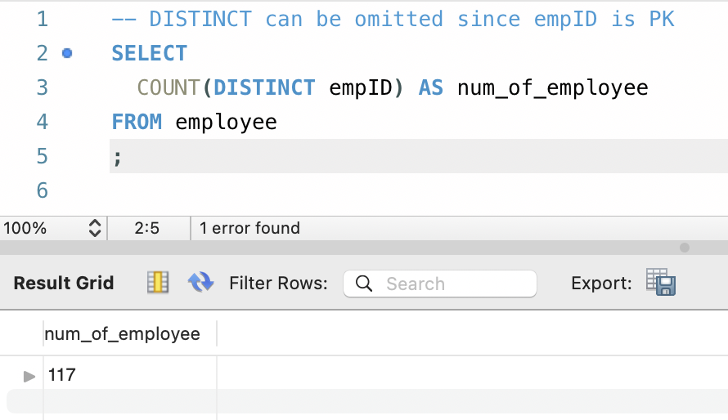

Answer for 1-5 <Submit screenshot of query and results>:
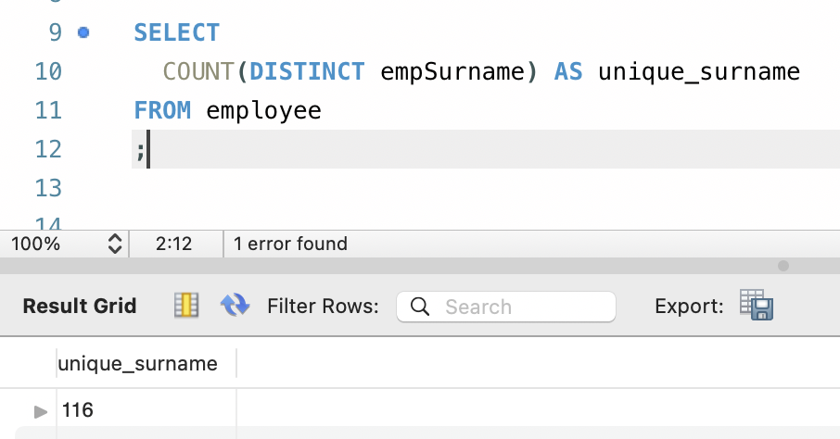

Answer for 1-6 <Submit screenshot of query and results – ensure all returned rows are visible >:
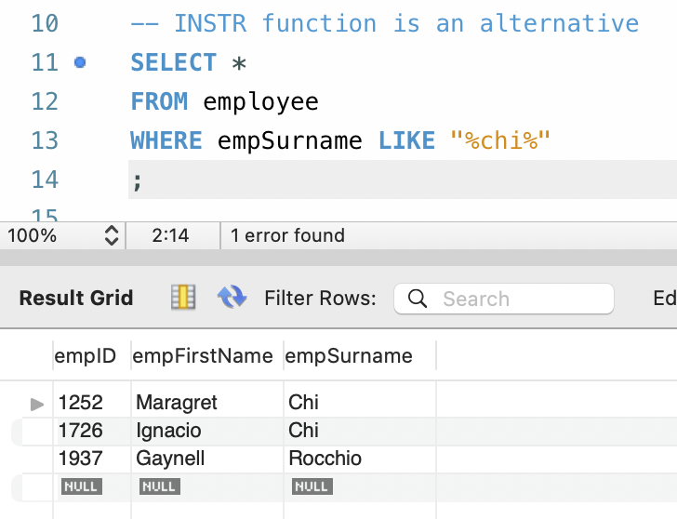

Answer for 1-7 <Submit screenshot of query and results>:
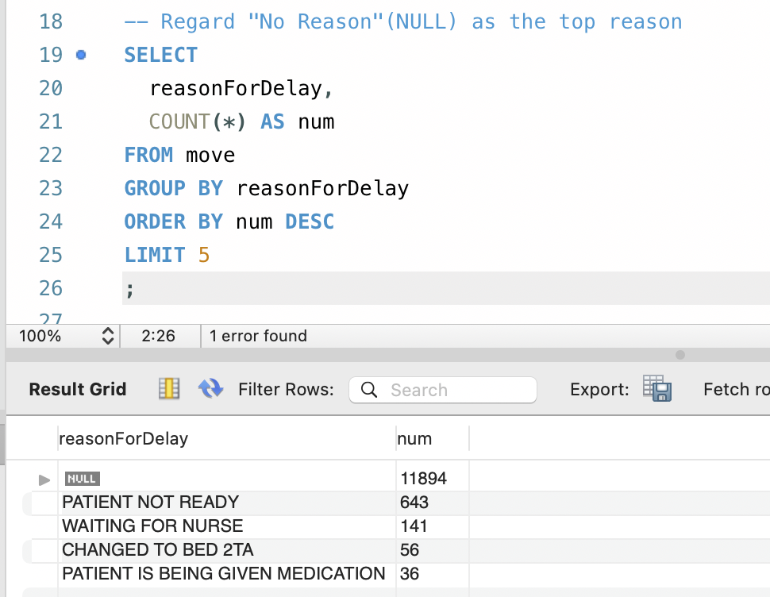

Answer for 1-8 <Submit screenshot of query and results>:
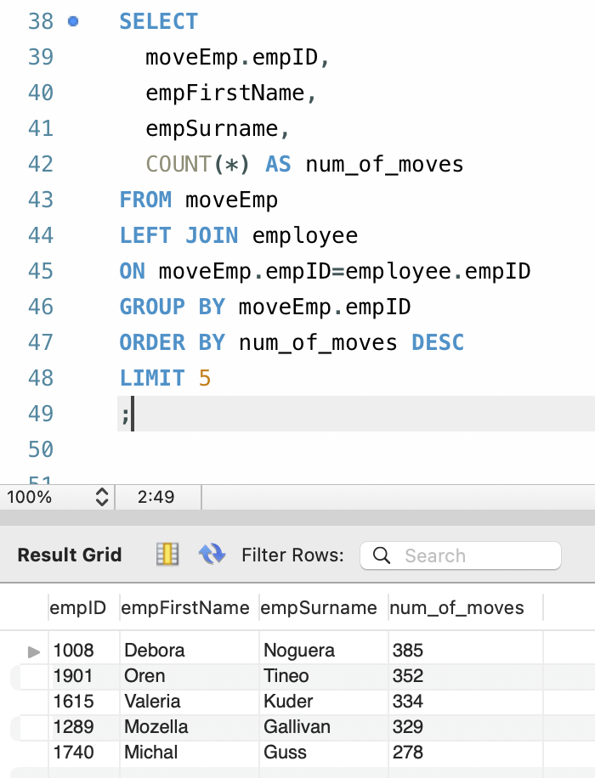

Answer for 1-9: D
(Compared to 1-11 and 1-12, this question is not ambiguous to me because it specifies tPortTypeId is ‘STRETCHER’. Please check the following notes in 1-11.)

Answer for 1-10: Complete table

toUnitID | fromUnitID | numMoves
ED XRAY NORTH | ED | 1288
ED | ED XRAY NORTH | 1220

Answer for 1-11 < Submit screenshot of query/queries and results >:
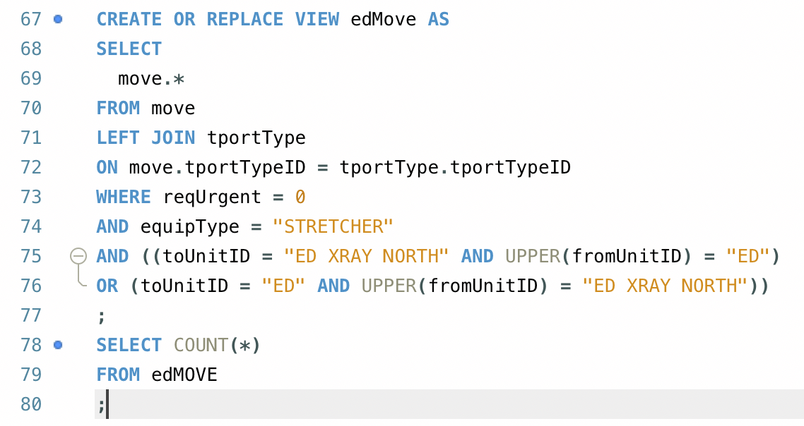
I was confused by the hint in this question. It says tportType=‘STRETCHER’ instead of tportTypeID as 1-9. I suppose the hint in the question should be equiType = “STRETCHER” to count in “STRETCHER 2 TA” (different from 1-9). After all, the results are the same in this case. There are 2258 rows. Same to the next question.

Answer for 1-12 < Submit screenshot that includes your CREATE VIEW statement and at least the first three rows of the output returned by the SELECT statement above >:
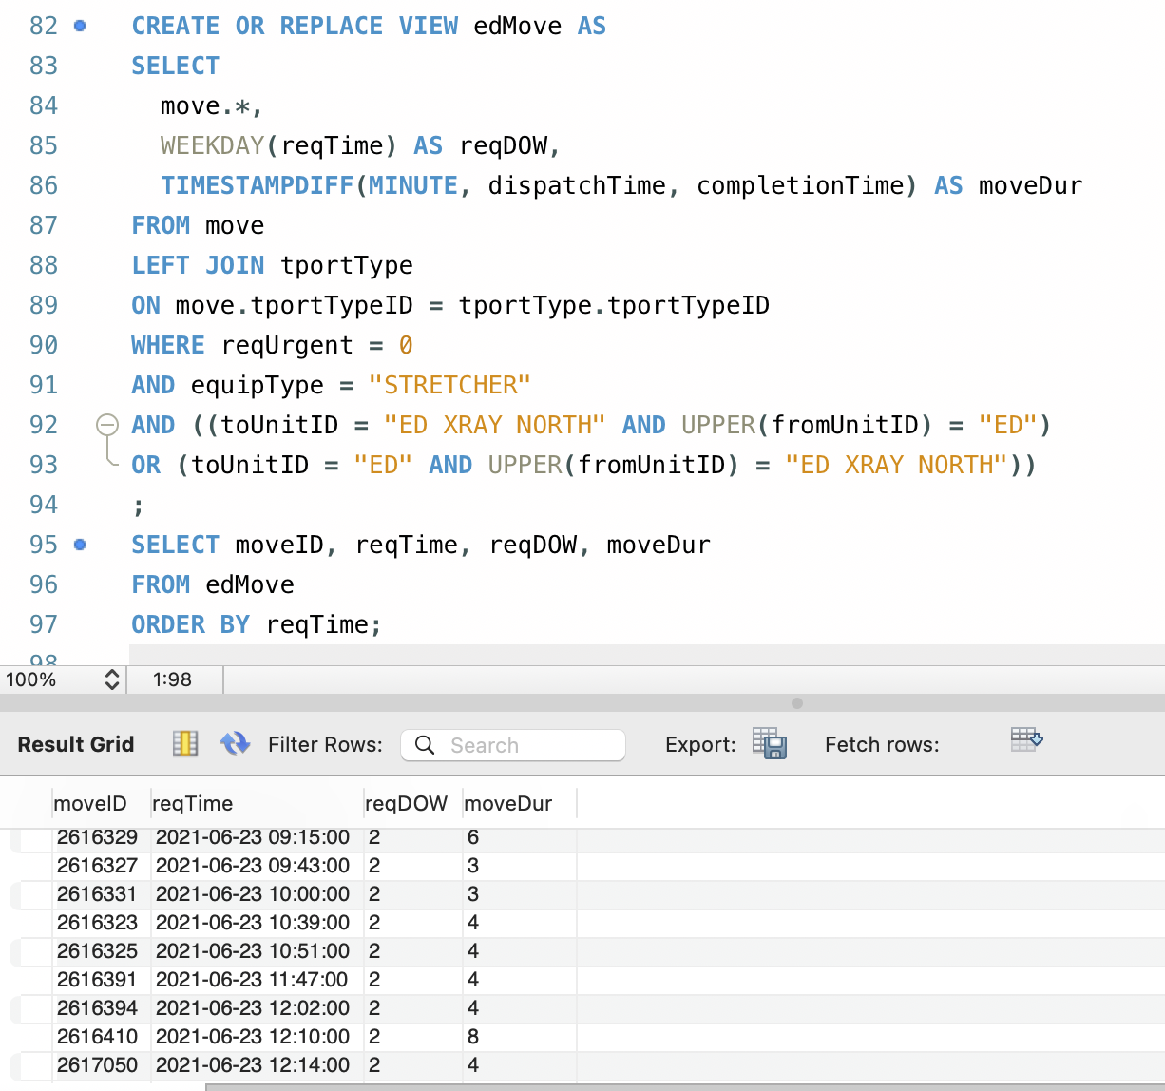

Answer for 1-13 <Submit screenshot of query and results>:
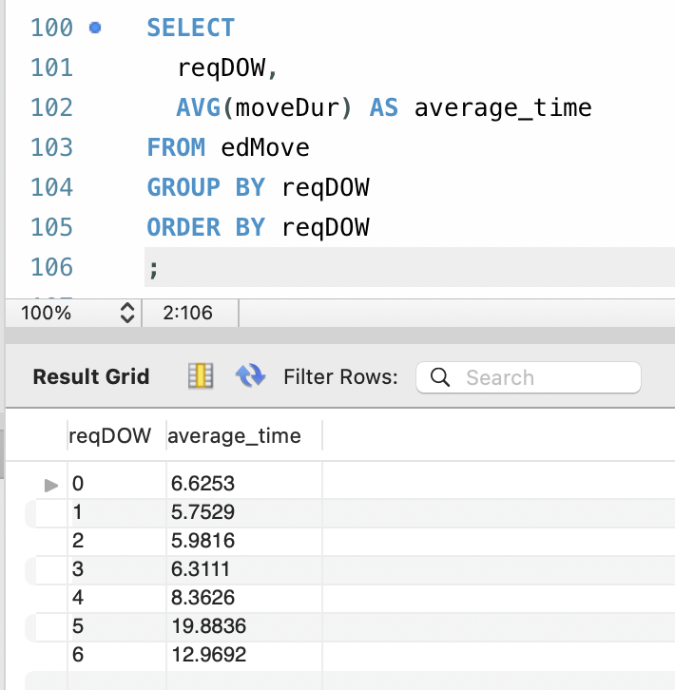

Answer for 1-14 <Submit screenshot of query and results>:
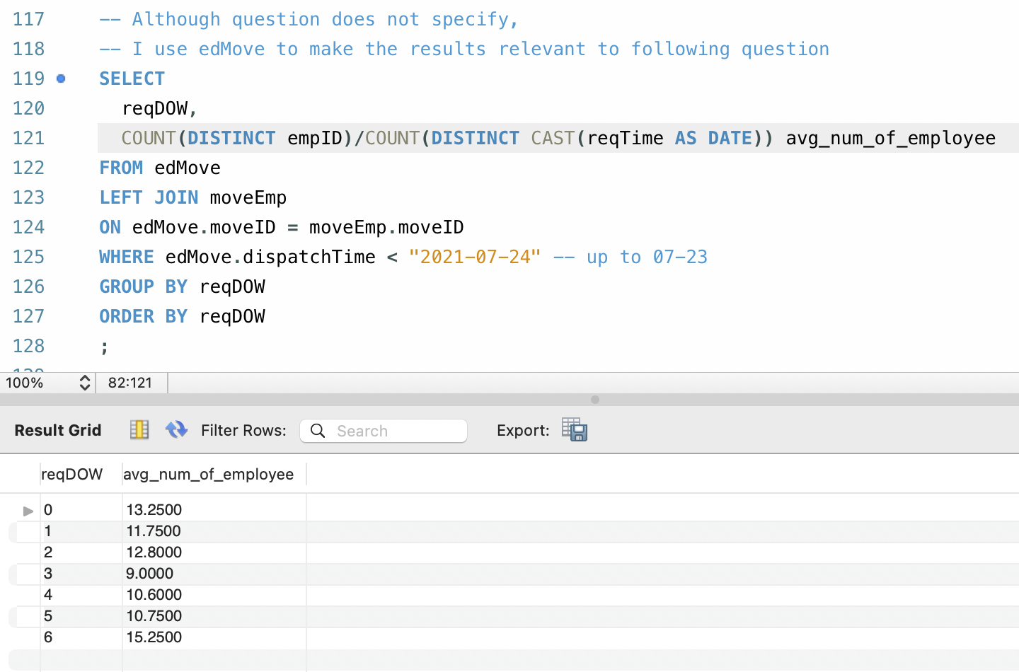

Answer for 1-15:
Based on the results from 1-13 and 1-14, I believe it’s fair to compare. The reason is on average, there is no peaks of the numbers of employees, of patients and of moves on weekends (days 5-6). Although Day 6 seems to be at a higher level, Day 2 is at an even higher demand level but still has a very low average dispatch time.
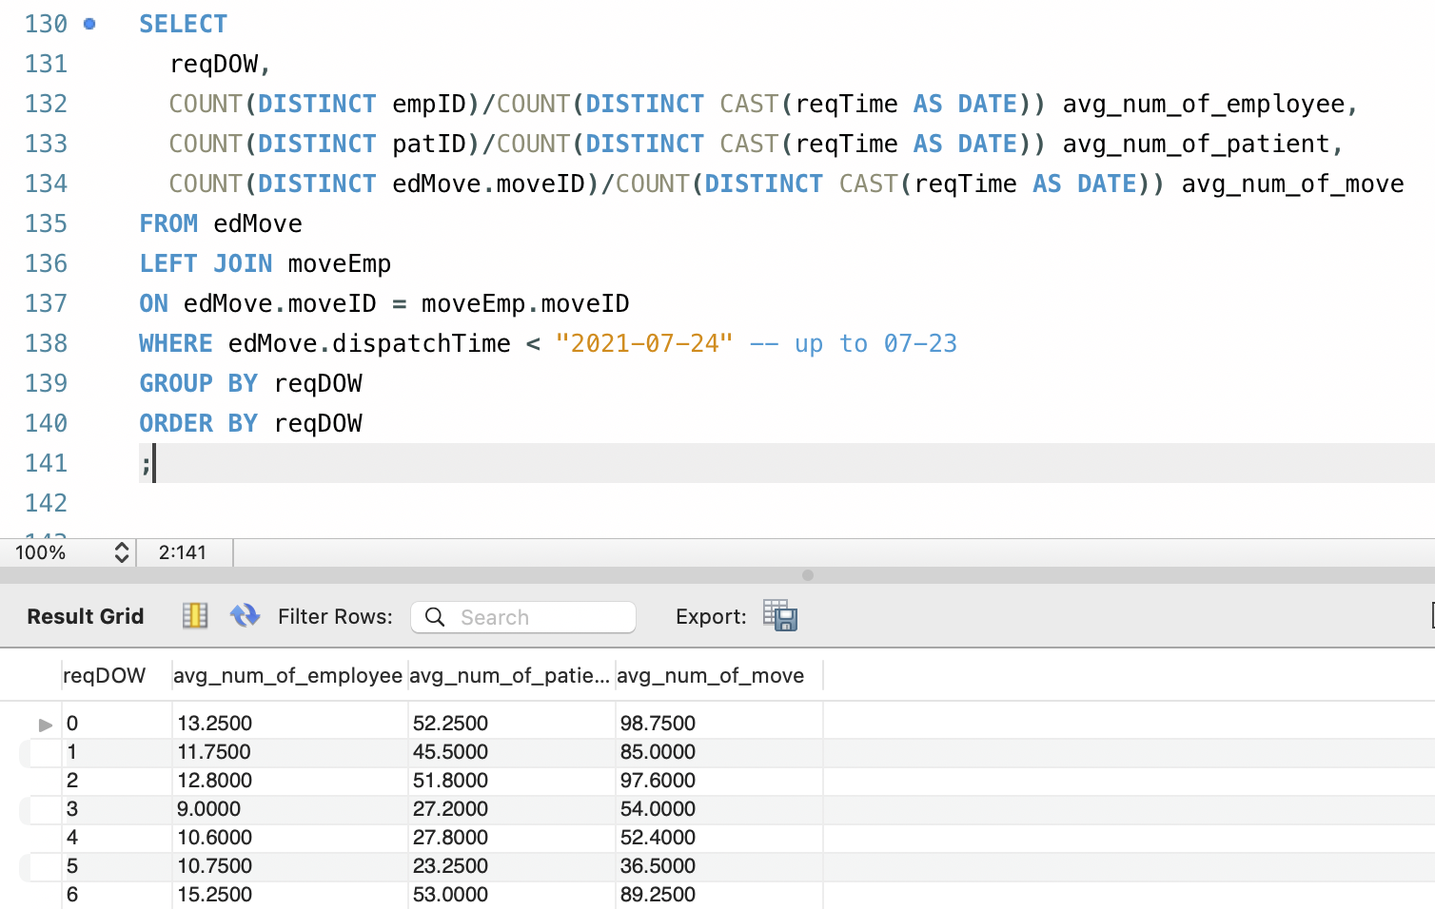

QUESTION 2

Answer for 2(a): <Submit your answer as an ERD. If it is hand drawn make sure that all parts are clearly visible and readable in the image summited>

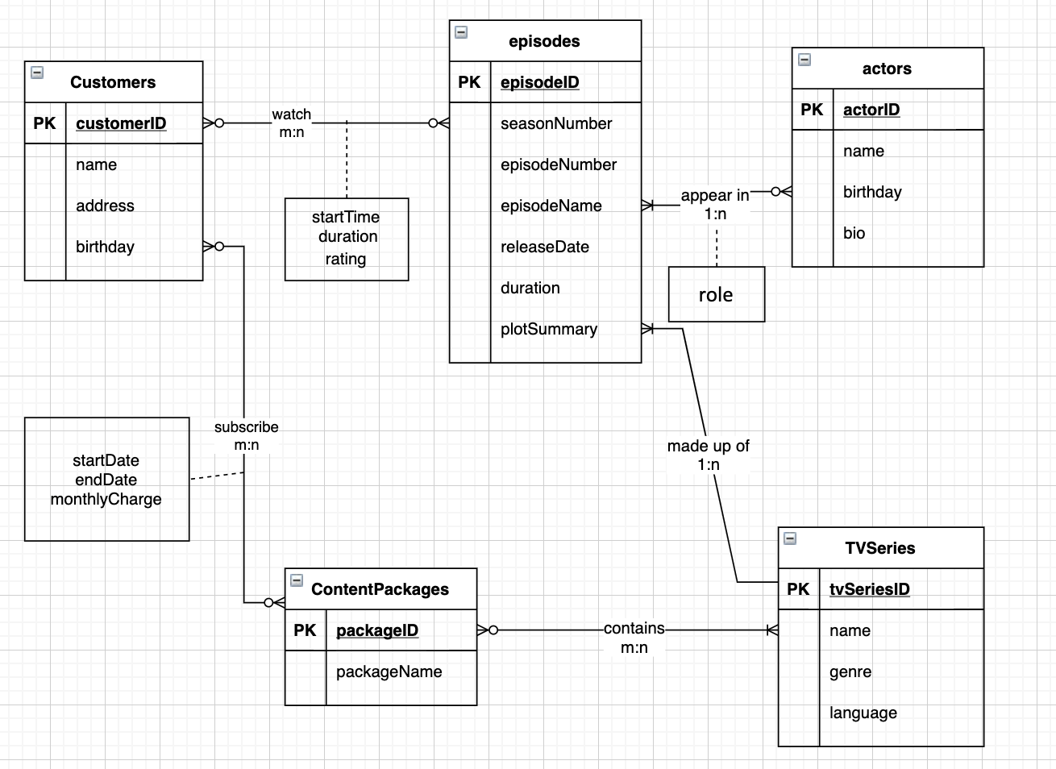
Answer for 2(b):
Customers (customerID, name, address, birthday)
ContentPackages (packageID, packageName*)
Subscriptions (fk_customerID, fk_packageID, startDate, endDate, monthlyCharge)
TVSeries (tvSeriesID, name, genre, language)
PackageSeries (fk_packageID, fk_tvSeriesID)
Episodes (episodeID, seasonNumber, episodeNumber, episodeName, releaseDate, duration, plotSummary, fk_tvSeriesID)
Actors (actorID, name, birthday, bio)
Appearance (fk_actorID, fk_episodeID, role)
Watches (fk_customerID, fk_episodeID, startTime, duration, rating)
Annotation: * Although package name is unique, creating an ID column can save space in the database and be more efficient.

QUESTION 3

Answer for 3(a): D

Answer for 3(b): No, it will not. In terms of systematical operation speed, they are almost the same. None of subqueries, VIEWS or CTEs will actually store the data in memory or disk. When running a query referencing them, the database must run them like subquery again to read and process the data. Although we can use them to improve readability and try to write more efficient SQL, they do not systematically increase the speed of query execution.

Answer for 3(c):
There are usually four steps in ETL:
E1 (Extract): to capture a snapshop of chosen source data
E2 (Scrub/Clease): to use pattern recognition and AI techniques to improve data quality
T (Transform): to convert data from format of operational system to format of data warehouse and at the right level of granularity in DW.
L (Load/Index): to place transformed data into the data warehouse and create indexes.

